Dice & Dudes

Reed Bader

University of Missouri – Kansas City

Table of Contents
Vision Statement 3
Requirements 4
Product Backlog 5
Sprint #1 6
Review 6
Retrospective 6
Sprint #2 7
Review 7
Retrospective 7
Sprint #3 8
Review 8
Retrospective 8
Sprint #4 9
Review 9
Retrospective 9
Sprint #5 10
Review 10
Retrospective 10
Sprint #6 11
Review 11
Retrospective 11

Vision Statement

I am planning to make an app that is based around tabletop games, the main features being a dice roller that adds your intended modifier, a sheet that can be changed, and different pages for different things. I think this is helpful because while there are applications for dice rolling and some for character sheets, I have not seen one for both and thought it would be a cool idea for the geeks like me. I plan to have it able to track stats, roll, keep a log of past rolls, have inputs if you find out what a success is. I have hopes to put in more kinds of pages for other table top games besides D&D, and also to be able to have the DM give a player an item through their device, but these are stretch goals.

Requirements
A discussion of what your application is required to have in functionality. It should identify user roles and goals/actions, and what the key features of the app should be.
Actor | Goal
Dice roller | create a dice roller with different kinds of buttons based on what is rolled
Stat page | Create a linked page to the roller for the player
backlog | Create a log of all previous rolls and what they were for
descriptors | Allow the user to add descriptors to what they want

Product Backlog
This will be updated throughout the semester as new PBIs are added, larger items are broken into smaller ones, and completed items removed.

Story ID | Story | Story Points  (in est. hours) | Priority | Status

Sprint #1

Sprint Backlog
Idk what to put here so it stays blank for now)
Story ID | Story / Task | Estimated  Hours | Actual  Hours
dice | Create dice rollers | 10 | 8

Review
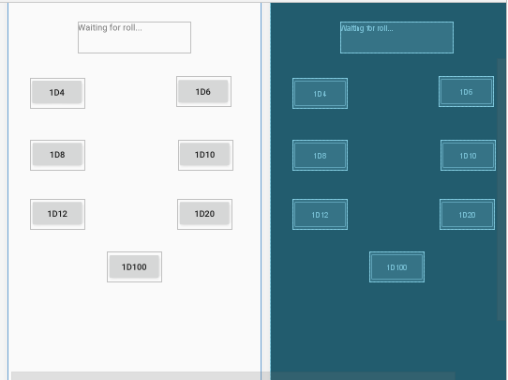

I created a series of buttons, while it does not look the best, I think it is functional. Later I plan to expand on them, but for now, this is what I will be working with. IT has 7 buttons and a text window, the buttons each correlate to a dice that can be rolled, and it sends that number to the random dice roller function. While it is not the best, I wanted to start small since I often have hardware issues when I start a large project.

Retrospective
I managed to create what I wanted, but I ran into an issue with my hardware of Vx-T not being active, so I need to figure out how to turn that on, before continuing. Later, But for now, it works and I am happy, now I need to figure out how to create a character sheet moving forward. I think for right now I will focus on the hardware issue and when that is solved, start with expanding into a second page with a character sheet.

Sprint #2

Sprint Backlog
Story ID | Story / Task | Estimated  Hours | Actual  Hours
pages | Make pages | 5 | 20

Review

I made an error. My laptop does not have a battery and became unplugged, and with it went most of my work because I forgot to save, so while I looked it up, I did not get it running

Retrospective
I was able to find a good source for making multiple tabs and decided to change up my idea of what to do. But due to an unfortunate error, I lost my work, so making those pages is going on the backlog for the for the next time

Sprint #3

Sprint Backlog
Story ID | Story / Task | Estimated  Hours | Actual  Hours
inventory | Create inventory page | 5
profile | Profile page | 5
backstory | Backstory page | 5
tabbed | Figure out tabbed app | 3

https://github.com/rmbgdf/CS449-RB/tree/Dnd/DND/DndApppart2imessedup

Review
There was an issue of both a computer issue being that my battery crapped out on me, my charger got cut and I couldn’t access any office file due to a corrupted file, so there were some setbacks, not to mention I am playing catch up, but I have figured out a little of making a tabbed app and I am working with my new app, DndApppart2imessedup long name but I makes sense in context. I will be working to get the physical parts down and then focus on coding them in
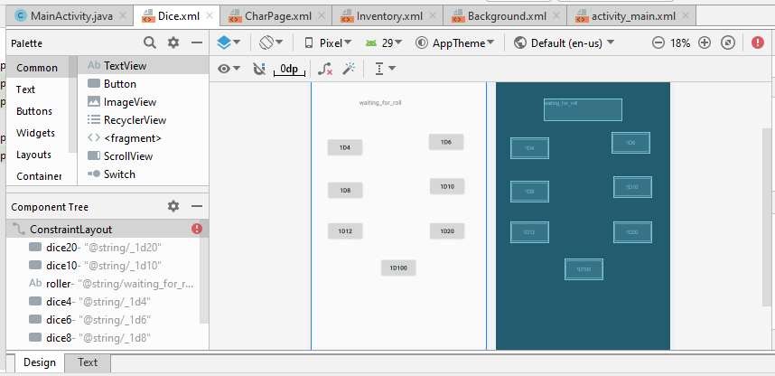

Retrospective
[This is where you discuss the process. What went well (and are you planning to do more of that?) What didn’t go so well (and do you have a way to do less of that)? What changes are you planning to make in how you plan & carry out the next sprint?]
I was able to get it all put together which was good, but there was a lot of physical issues due to outside factors. Due to that, I plan to work on it a little at a time, starting with the front end things and then taking a step into the coding once I have a better understanding of the format

Sprint #4

Sprint Backlog
Story ID | Story / Task | Estimated  Hours | Actual  Hours
Background | Figure out how to make a background you can put a lot in and edit | 3 | dropped
code | Figure out how to link and code tabs | 10
inventory | An editable and large inventory | 3 | 3
skills | Create skills board | 5

Review
With the high tensions, I had a family emergency around easter, to the point I was more focused on personal safety and everything like that, but it went over easy, however, I was not able to sleep or focus due to stress so I did not get much work done. I also really need to start asking questions about coding with android studio, as many of my issues stem from being unable to edit what I need.
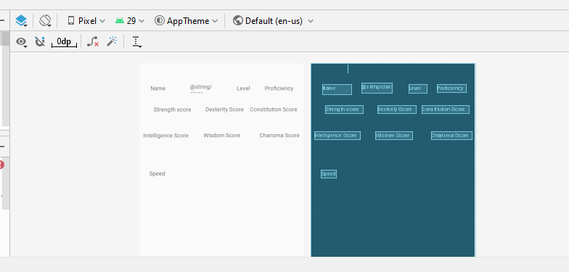

Retrospective
I was able to get the scores down, and I am feeling good with having a plan for what to do, but a lot went wrong, more than any other time before. I will be both asking for a person call with Hare and posting some questions in discussions to see what help I can get

Sprint #5

Sprint Backlog
Story ID | Story / Task | Estimated  Hours | Actual  Hours
code | Figure out tabbed coding | 15 | X
skills | Make the skills lay out to see proficency3 | 3 | X

Review
https://github.com/rmbgdf/CS449-RB/tree/Dnd/DND

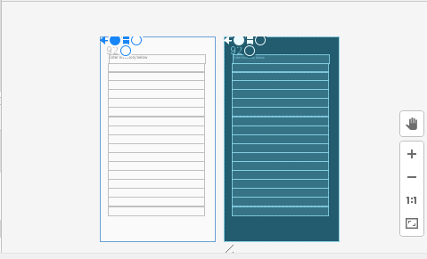
Created the inventory page using several notes (each line holds 1 of a kind of item, much like a character sheet. I decided to drop background as it seemed like it was not gonna be any more useful to add it. All I need to do is add skills (bunch of switches and I have a character sheet, it will just take time) and figure the coding out, as I can’t find any good resources for tabbed apps.

Retrospective
I was spitballing ideas and asked both hare and the discussion bored for ideas and tips for how to make the items. In the end, I went with a basic design that doesn’t affect much and is not intuitive because that is all it needs to be. Still trying to get on track with the coding, but I am not finding anything that would be particularly useful so I am working to figure it out. I had the idea to replace Background with skills, as background is just flavor that has no bearing on the end result, but skills are a necessary thing. A bunch of switches to show if you have a proficiency should be good

Sprint #6

Sprint Backlog
Story ID | Story / Task | Estimated  Hours | Actual  Hours
code | Figuring out code
skills | Skills page

Review

In the end, I could not figure out how in the world I was supposed to do Tabbed coding. I looked at several resources, but I could never get it to work, so sadly with no time left, I just made sure to get each part of what I would have put into the tabbed finished. Dice roller complete, a character page you can work on, and the inventory. Since skills was no made yet, and I didn’t have the tabs, I figured I would save that for when I figure it out.

https://github.com/rmbgdf/CS449-RB/tree/Dnd/DND/FInal%20itteration

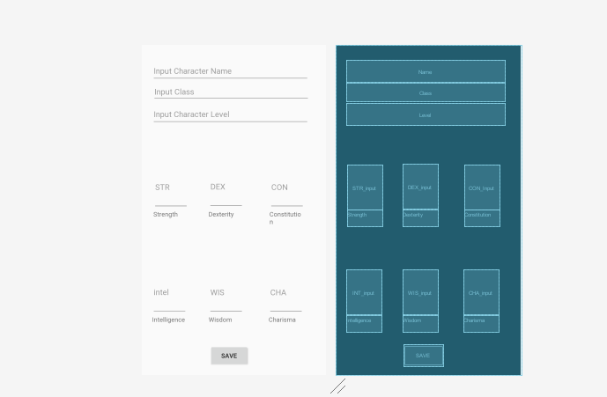

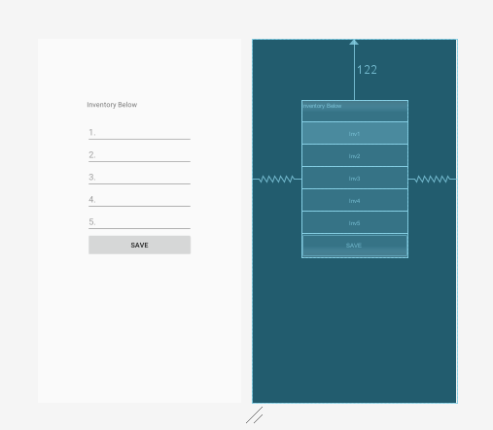

Retrospective
I find it in bad taste to leave something unfinished, but with the fact I could not get an answer to tabbed programing, and the sources I looked up were as confusing as I was unsure on what to do, I ultimately could not get it done. I have been looking since the start of the semester for something to help make sense of it, but found nothing, so I settled on making 3 finished parts of what I would add to my whole.

